Playwright-Typescript

Playwright link - https://playwright.dev/docs/test-typescript
Installation
Node.js, Typescript compiler, VSCode Editor,create a project in file explorer,open created project in Vscode editor,go to terminal in VS code editor and Give “npm init playwright@latest”

1.Node JS Installation
Step1
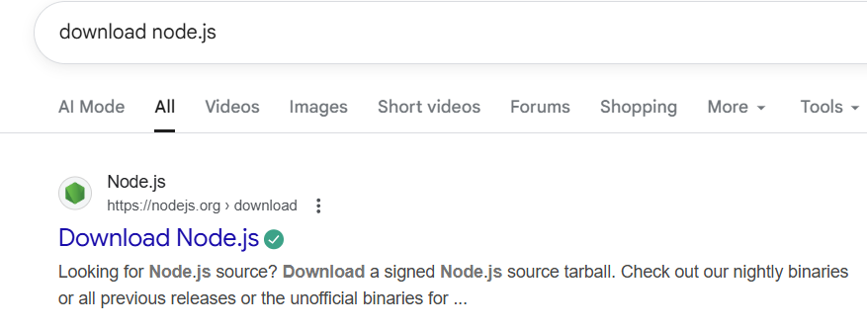
Step2
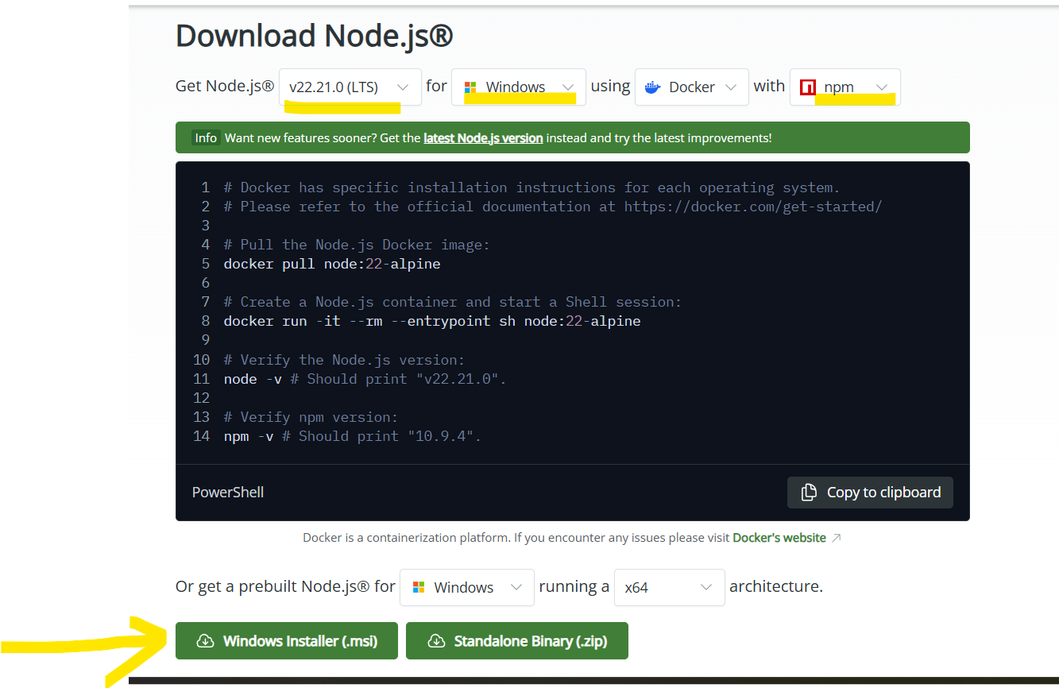
Step3
Go to Download section and see downlaoded file
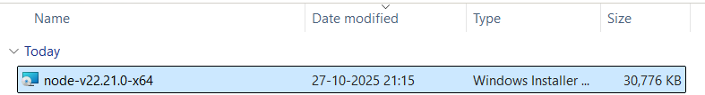
Double click on file

Step4
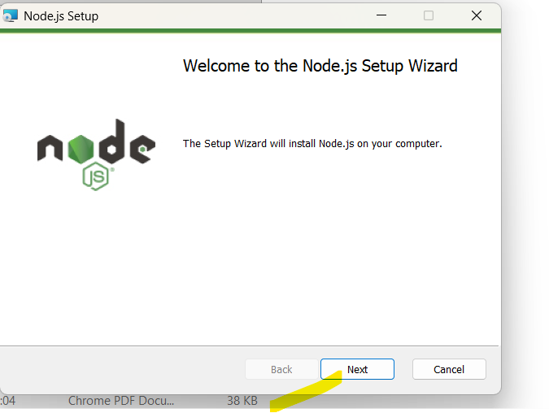
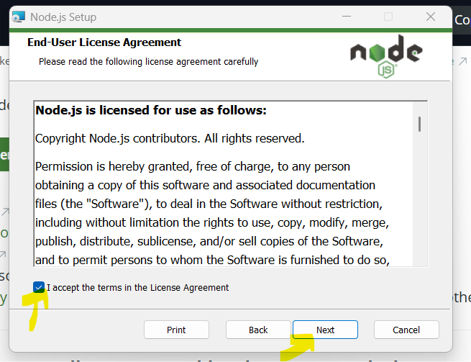

C:\Program Files\nodejs\

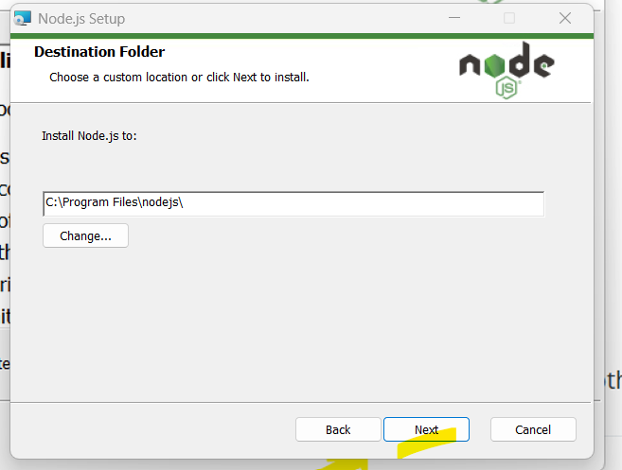
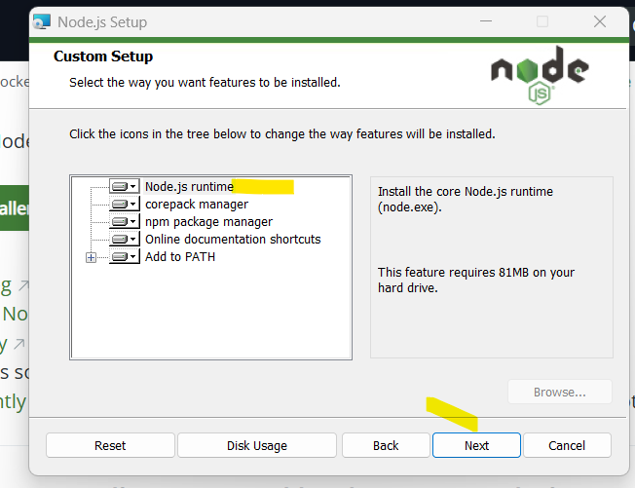

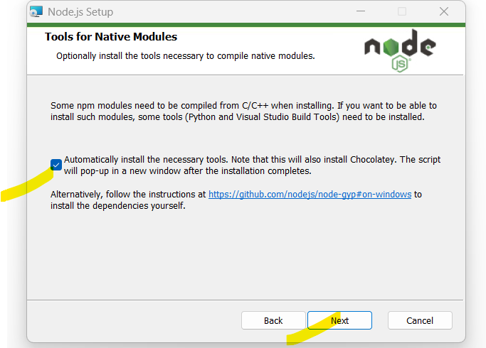
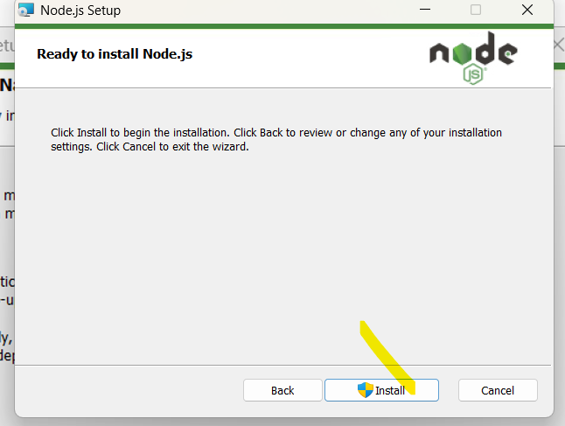

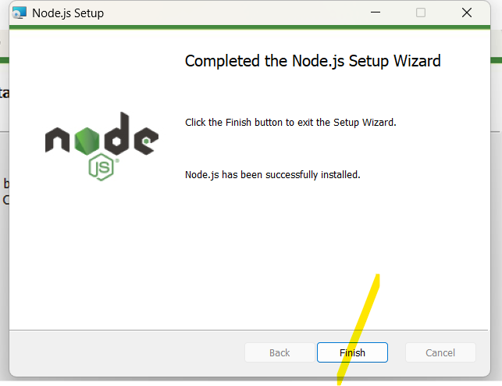

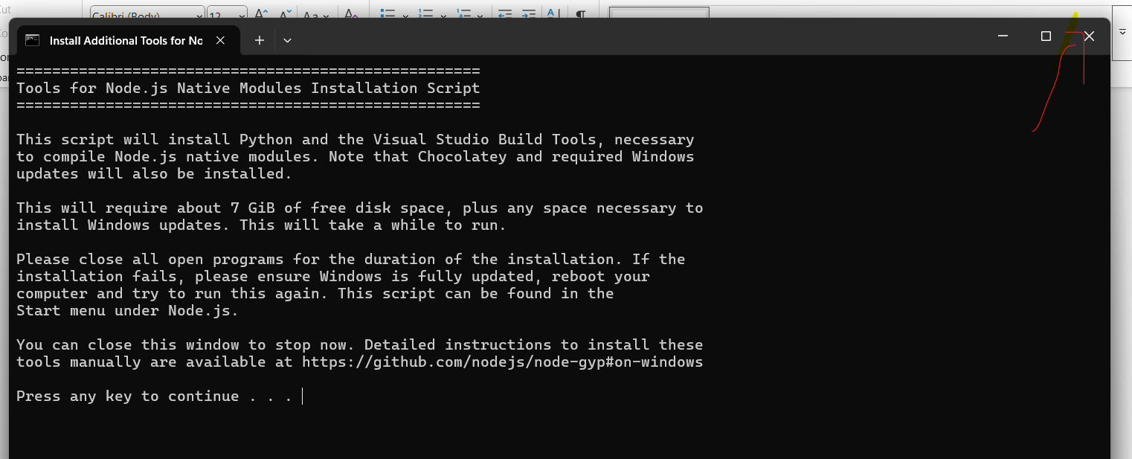

Verify if Node.Js installed successfully
Go to prompt and give “node -V”
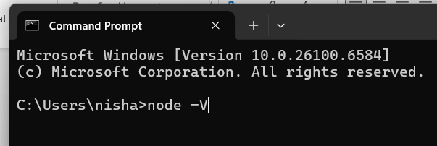

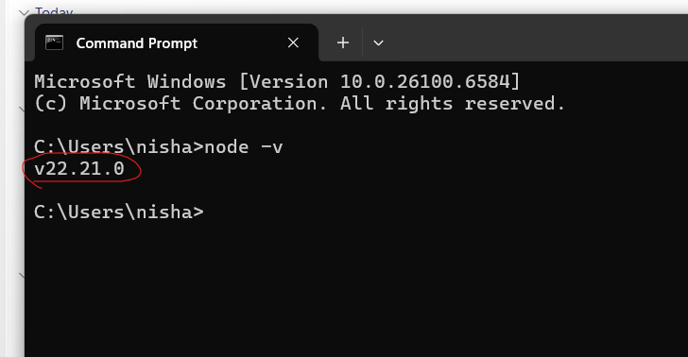
Set up file path
Go to the path C:\Program Files\nodejs\
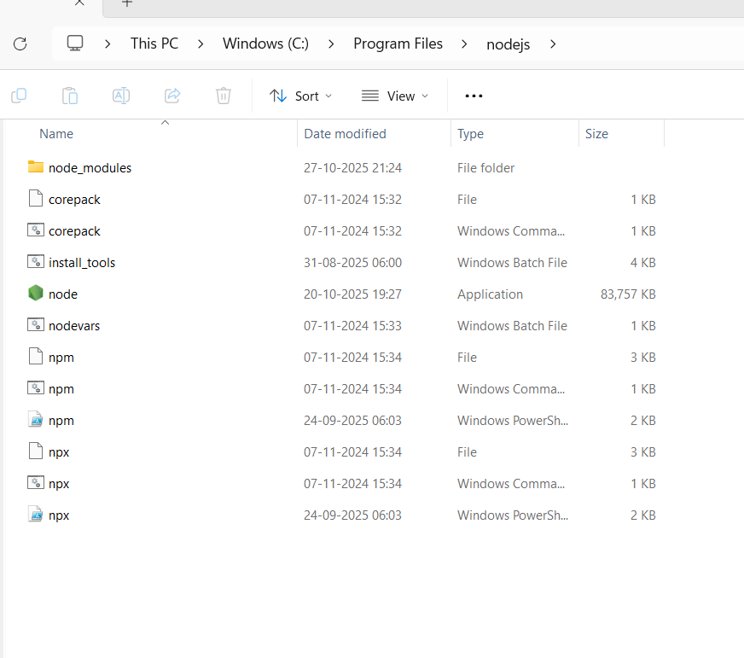

Go to advanced system setting - Environmental variables – System Variables – Path
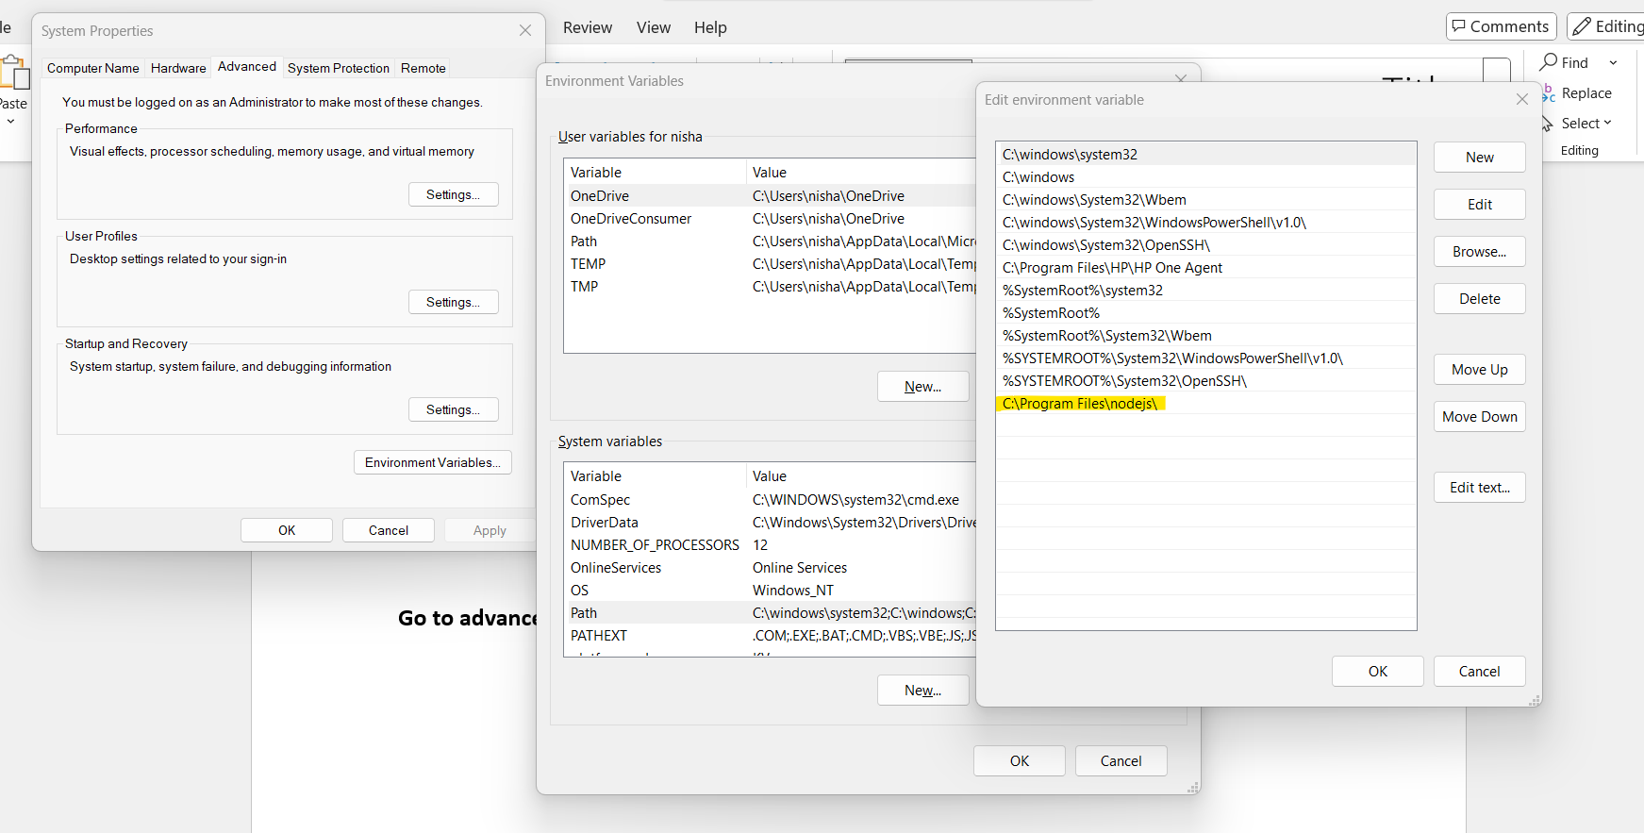

Go to below path and copy
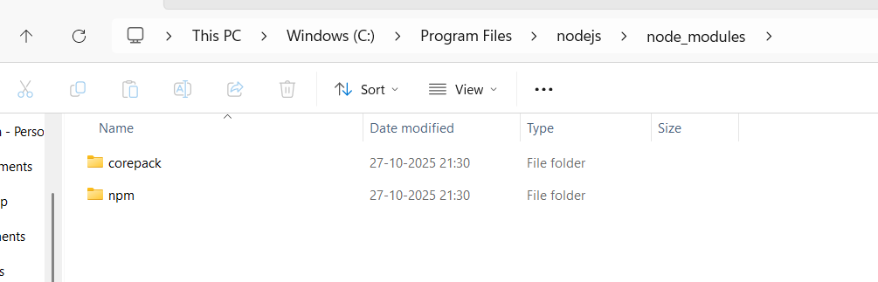

Add to environment variables
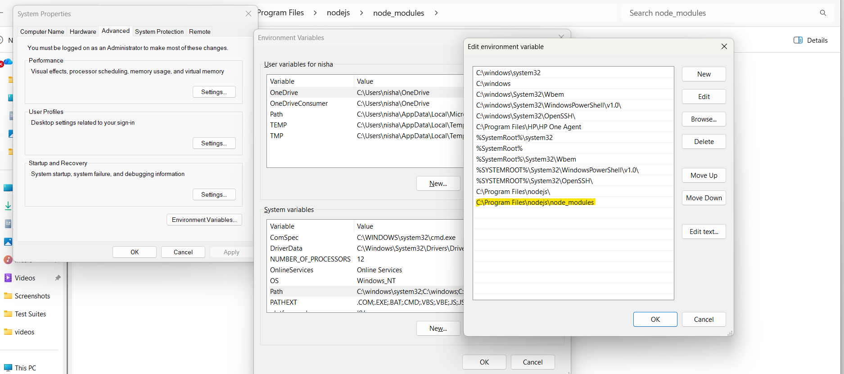

2.Install Typescript compiler
Check npm version in CMD
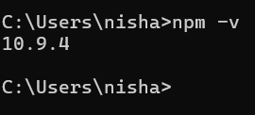
npm is a package manager for Node.js. It helps developers install, update, remove, and manage reusable code libraries (packages) in a project.
npm (Node Package Manager) is the default package manager that comes with Node.js. It allows developers to install and manage third-party libraries, track project dependencies through package.json, and run project scripts.
npm is a tool that downloads and manages the external libraries and tools a Node.js/TypeScript project needs.

Stores them in node_modules
Records the dependency in package.json

"...update..."
Packages release new versions with bug fixes and features.
Example:
npm update
npm can update dependencies according to your project's version rules.

"...remove..."
If a package is no longer needed:
npm uninstall express
npm removes it and updates the project's dependency information.

6. "...manage reusable code libraries (packages)..."
A package is reusable code written by someone else.
Examples:
- Express.js – web server framework
- Axios – API requests
- Lodash – utility functions
Instead of writing these features from scratch, developers install and use them.

7. "...in a project"
npm keeps track of project dependencies using files such as:
package.json
package-lock.json
This means another developer can clone the project and run:
npm install
and npm will install all required packages automatically.

Give npm install -g typescript
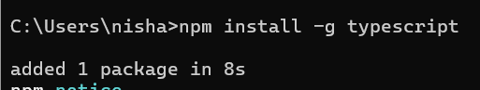

3.Download VScode editor
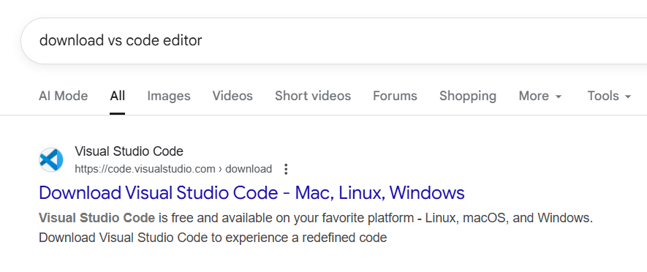
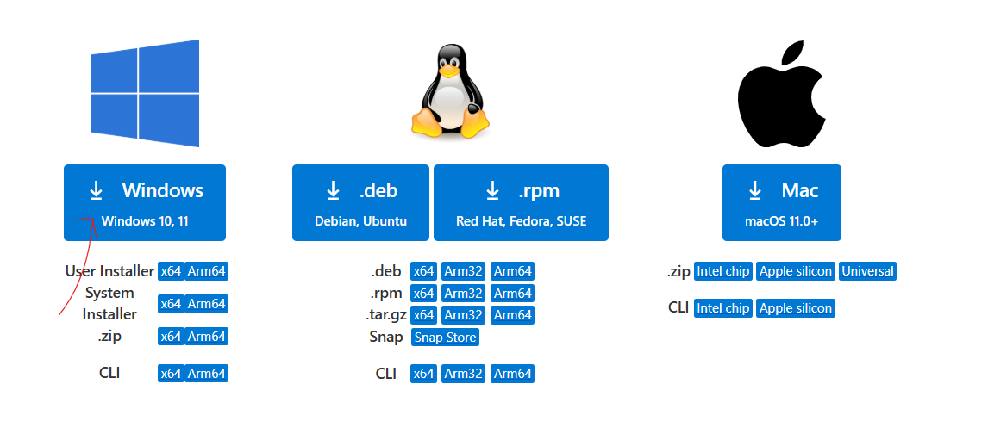

Go to downloads
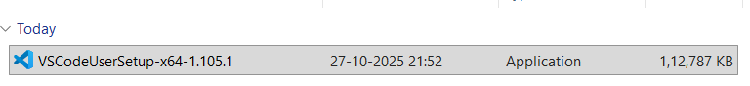

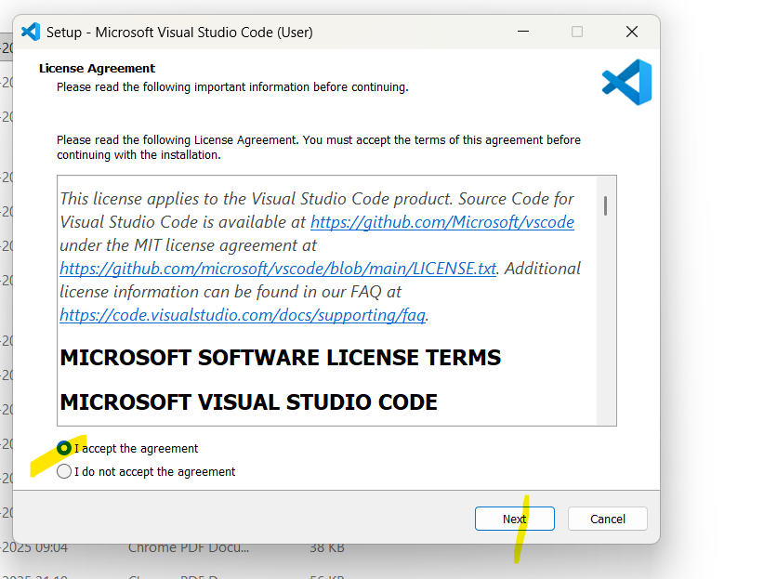

C:\Users\nisha\AppData\Local\Programs\Microsoft VS Code

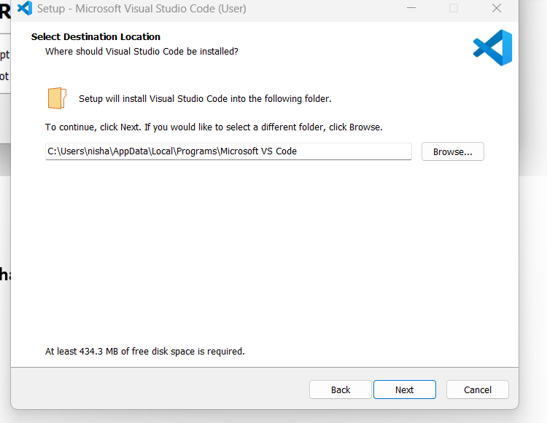

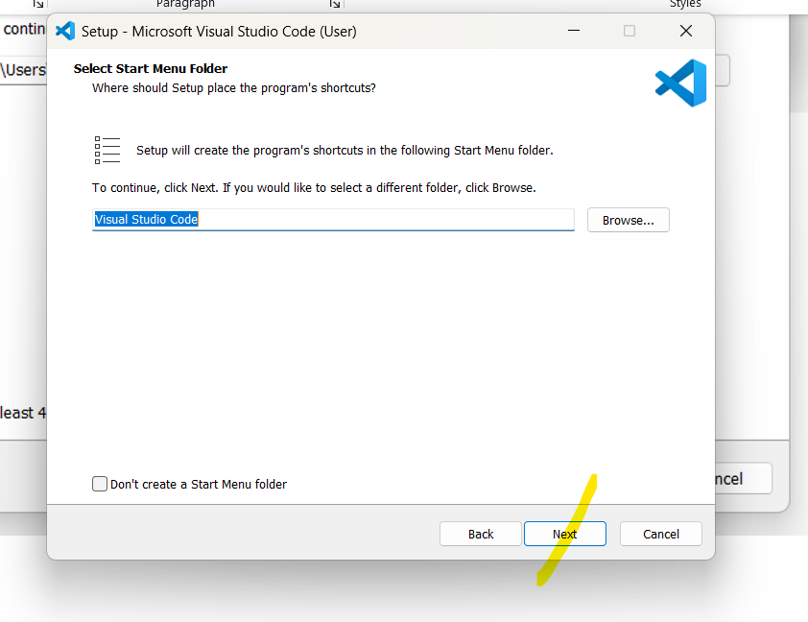
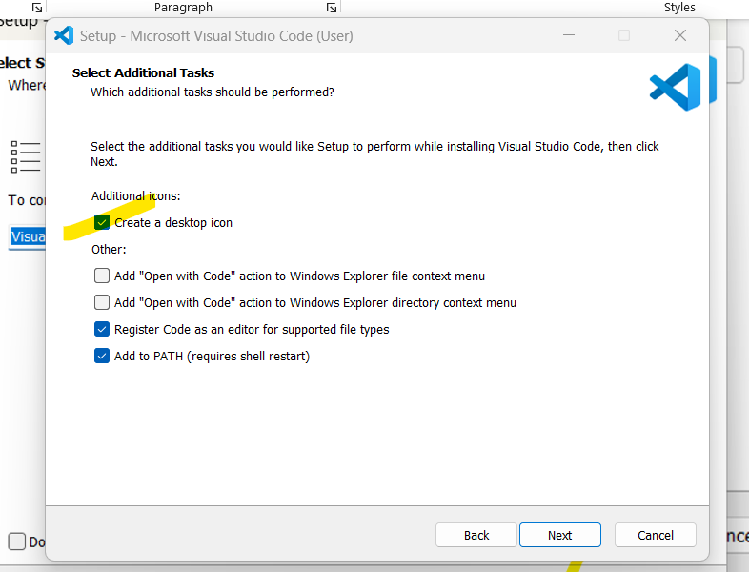

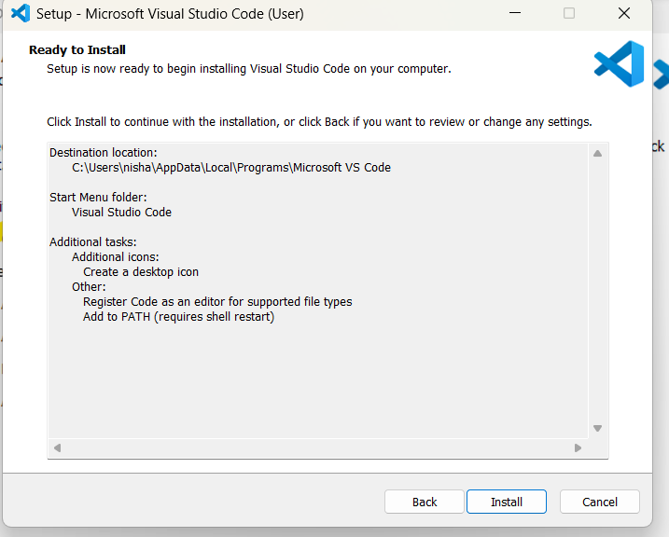

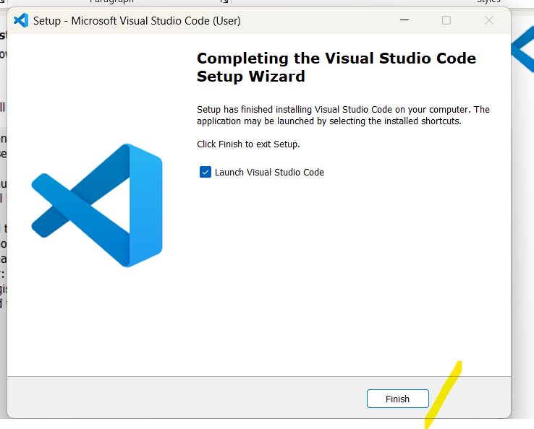
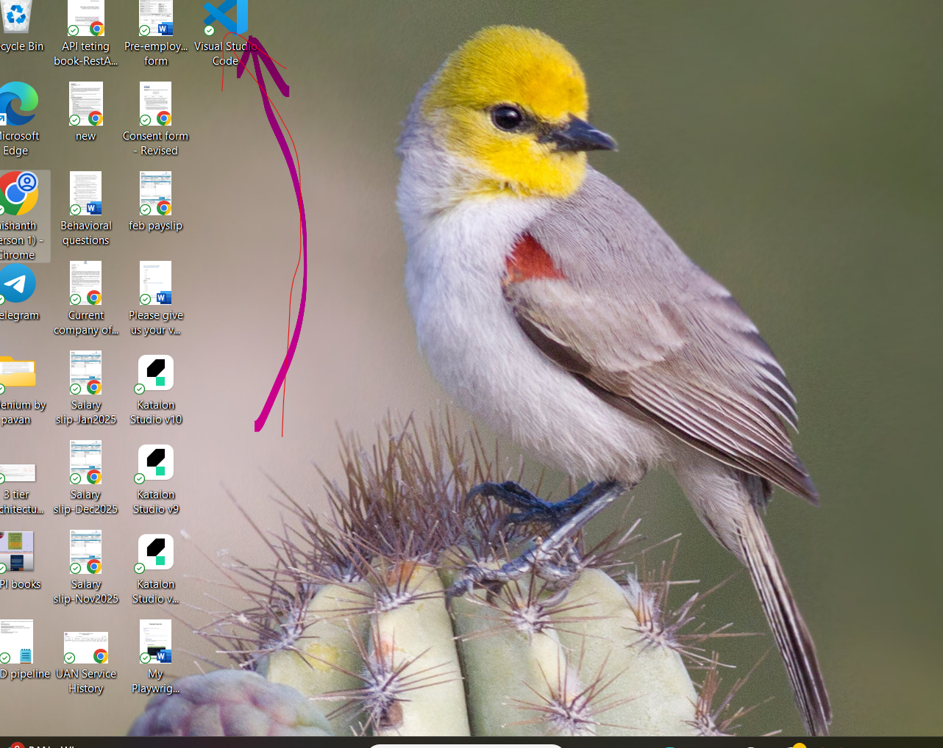

4.Playwright installation
Create project in file explorer
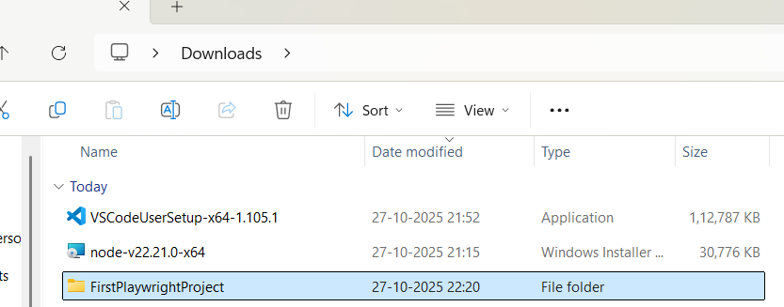
Open VS code editor and project
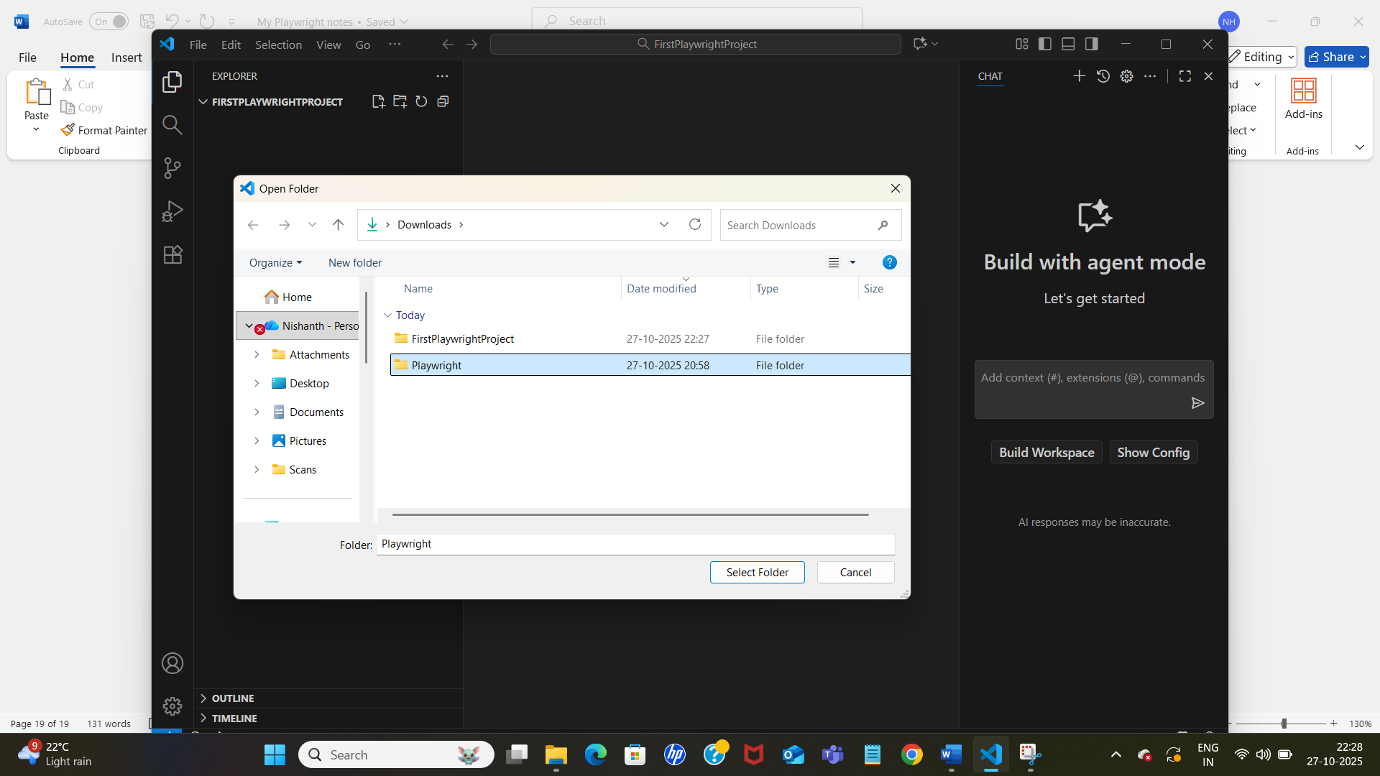

Go to new terminal
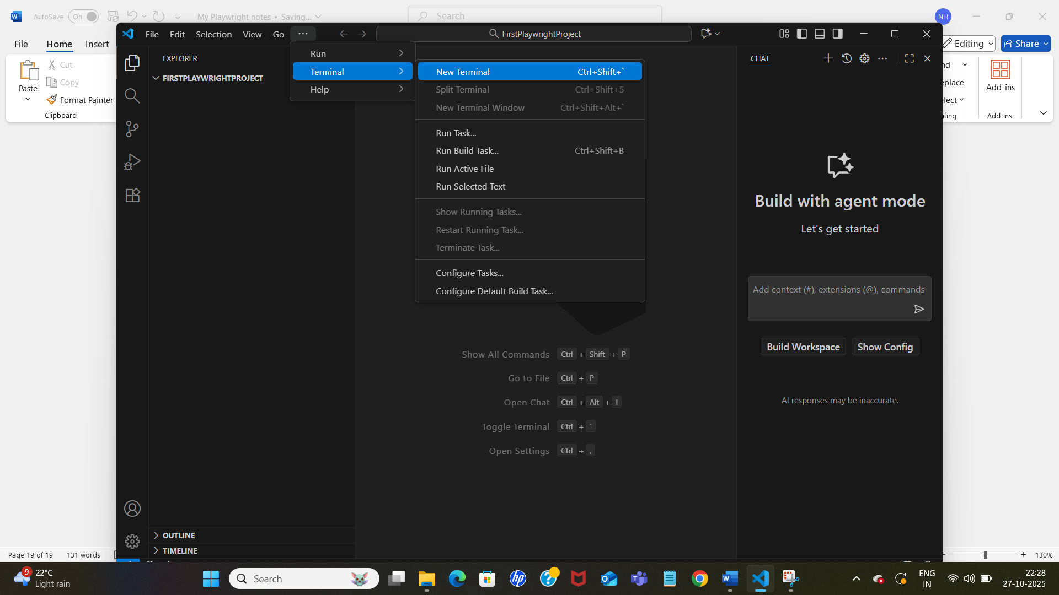

Give npm init playwright@latest in terminal
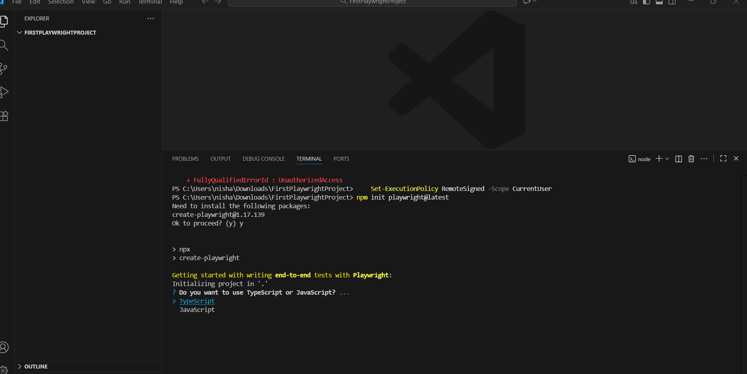

Press enter
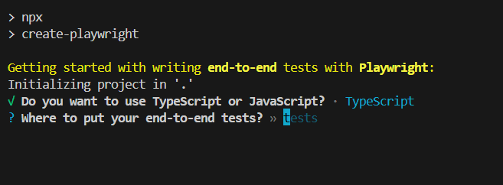

Press enter
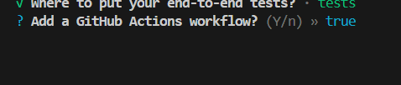

Press enter
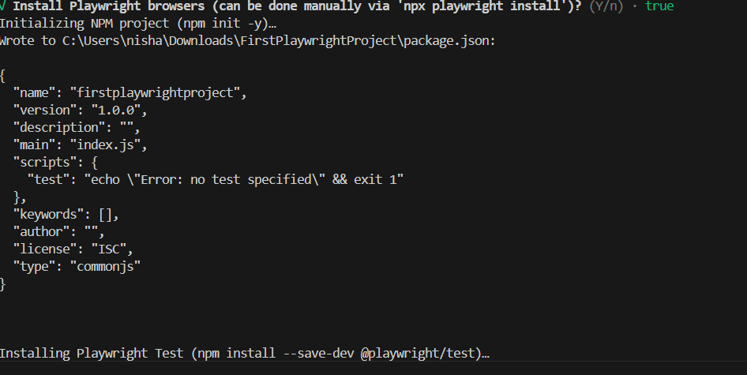

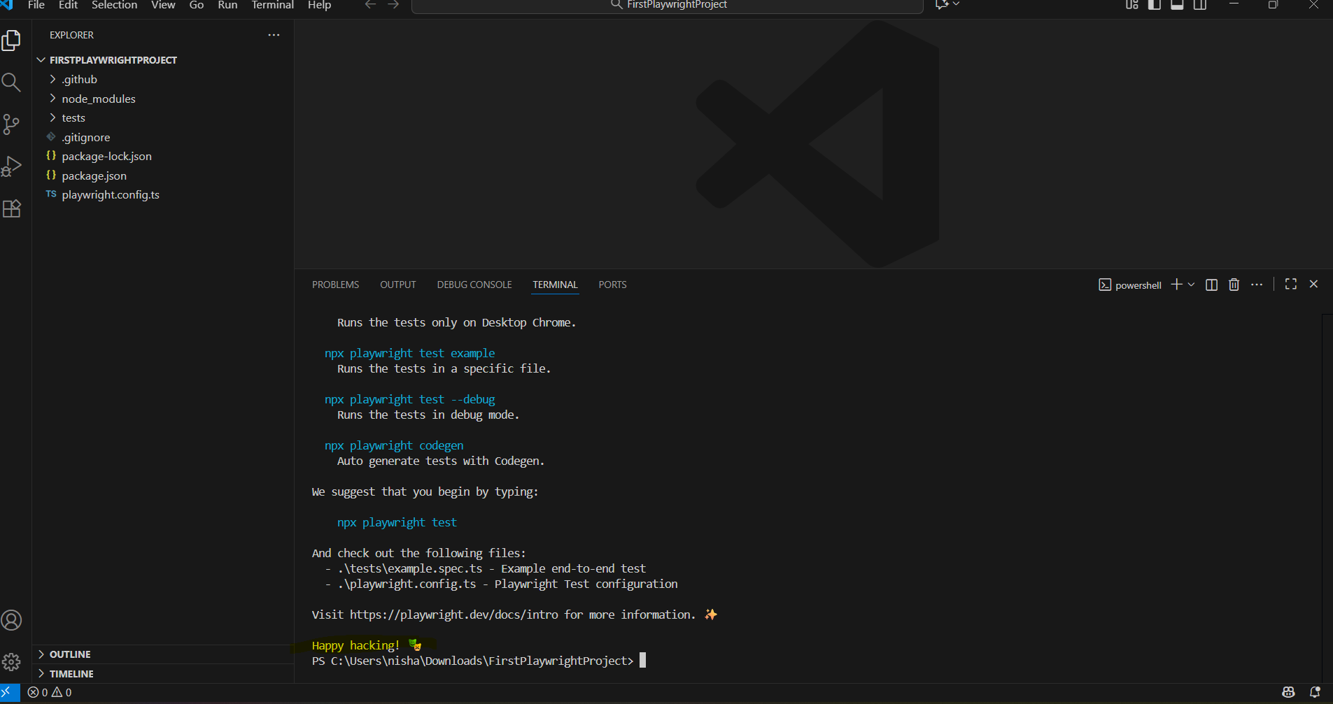

when we download node.js it will come with npm
to update node.js, we have to install updated version, updated version will replace old one

node -v
npm -v
**************************************************************************
VS code editor update
Updating VS Code is usually straightforward.

Windows
Method 1: Automatic update (most common)

VS Code checks for updates automatically.

You can manually check:

Open VS Code.
Click Help → Check for Updates.
If an update is available, VS Code downloads it.
Restart VS Code when prompted.

***************************************************************************
package update

playwright

3. Install the latest version of a specific package

For example:

npm install express@latest

or

npm install lodash@latest

This updates both the installed package and package.json.

Upgrade to a specific version
npm install express@5.0.0
**************************************************************************

